Group 2 Visualization Project.

In This document we wrote a report for all 1 to 7 questions with the requested details given in question 8.

**1. The CEO wishes to see information about the profits and sales per product category during the last three years. Therefore, create effective visuals that present the sales per product category and the profits per product category for the last three years.**

**Title:** Aim is to draw information about profits and sales per product category during last three years.

**Summary:** Let us investigate the key points to visualize the report in best way possible:

* Concentrating on profits and sales as per product category for certain duration.

**Introduction:**

We are extracting data of profits and sales from the orders dataset. And visualizing the data in graphical representation to make the audience understand the visualization is most effective way.

**Methods and findings:**

To draw the required visualization from the requirement we need to follow the instructions.

* After trying different graphs and plots, this horizontal bar graph helps us to visualize the report in the most efficient way.
* Drag and drop the profit and sales from measures to the columns.
* Drag and drop the category and order data in the rows.
* To get the last three years data we use filters on order data and select only the years that are required.
* To get the data that the bars are carrying drag and drop the sales and profit fields to the label.
* And to show different color intensity based on the profits it carry, we need to drag and drop the profit to the color.

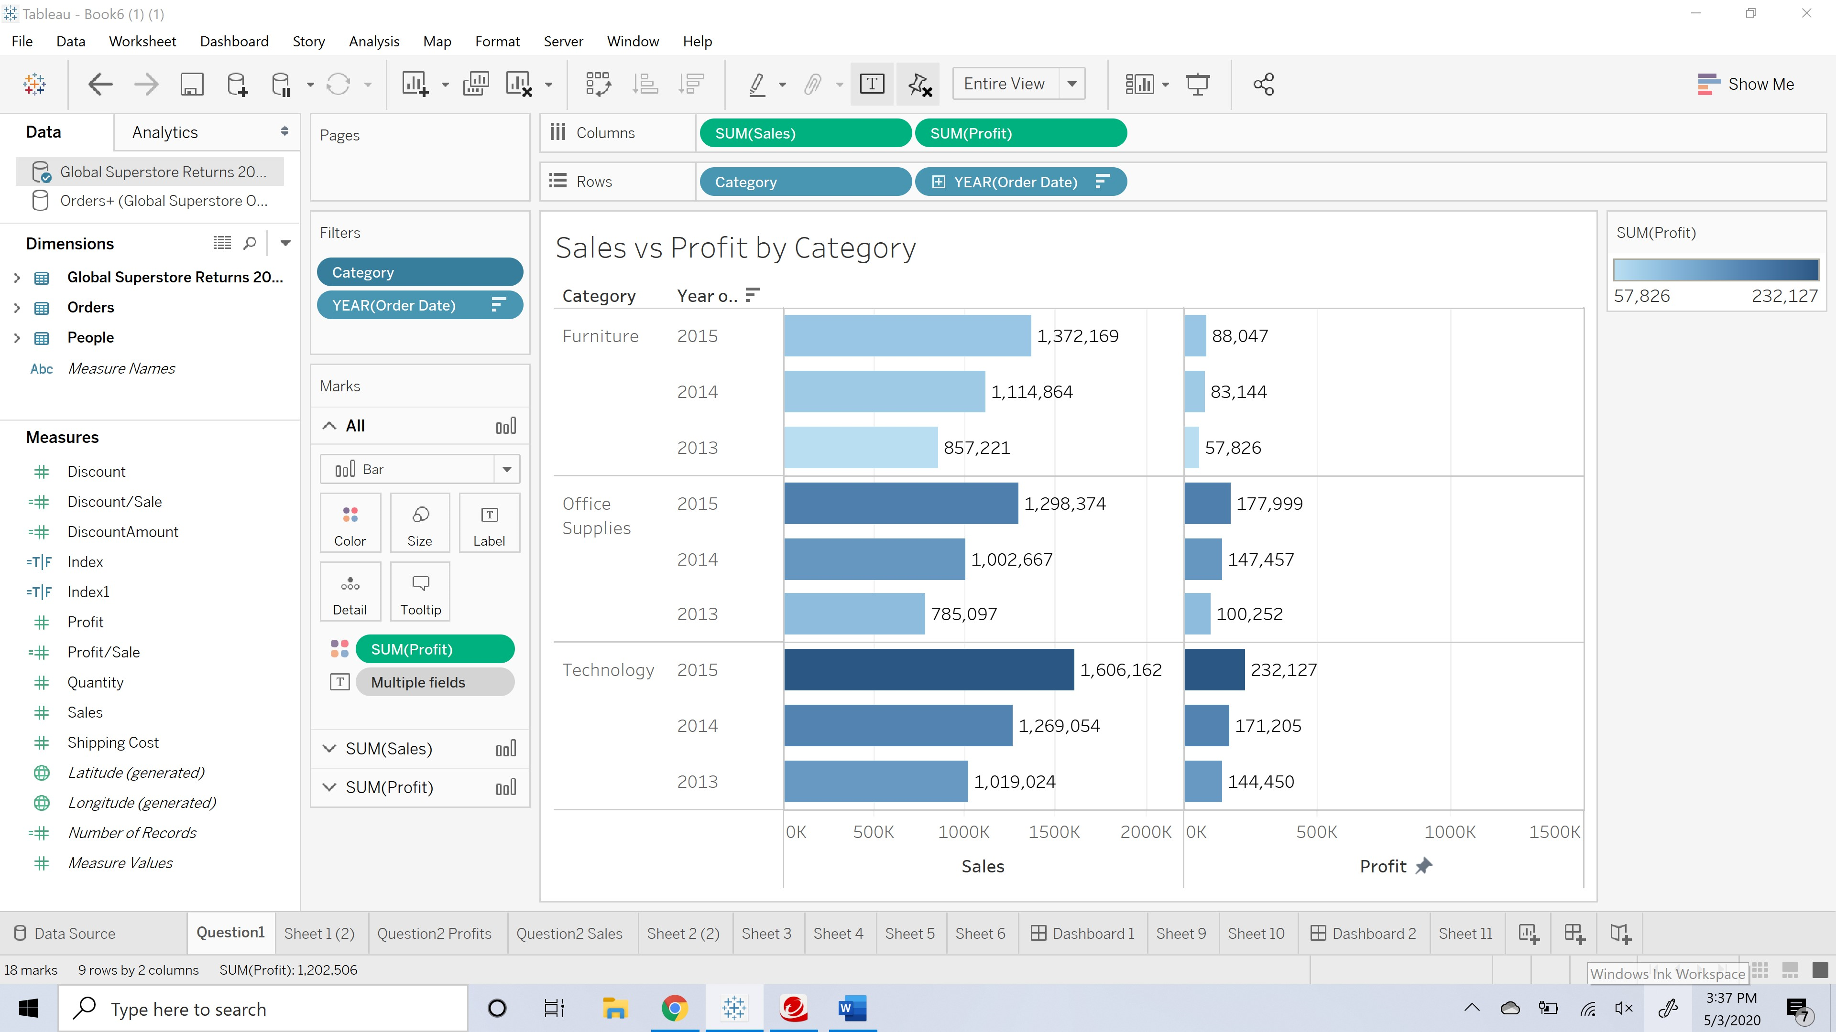

**Conclusion:**

So, this report shows the profit and sales per product category for last three years with labeling as well.

**References:**

1. Tableau training sections.
2. Class learning modules.

**2. Make clear which countries are the most profitable for the company and the profits per product category. In addition, the CEO wants to see the products sales with the least sales for some product categories, thus find out the countries with the lowest level of sales during the last three years.**

**To find out most profitable countries:**

**Title:** Aim is to detect countries which has the most profitable profits per product category during the last three years.

**Summary:** In this report we are looking for the most profitable country per product category.

* We use only concentrated on the orders data set.
* Creating new parameter to find the top sales.

**Introduction:**

We consider mainly the orders dataset and used the data that is required to obtain the desired result of visualization. Our main purpose is to get the country which has most profitable for the company.

**Methods and findings:**

To draw a required visualization from the requirement we need to follow the instructions.

* After trying different graphs and plots, this horizontal bar graph helps us to visualize the report in the most efficient way.
* Drag and drop the country and category from dimensions to the rows.
* Drag and drop the sum of profits to the text, color in marks and on to the columns as well.
* To get the last three years data we use filters on order date and select only the years that are required.
* Now create a new parameter and name it as index which carries a mathematical equation to measure the top few countries which has most profitable sales.

**Screen shot of the above visualization:**

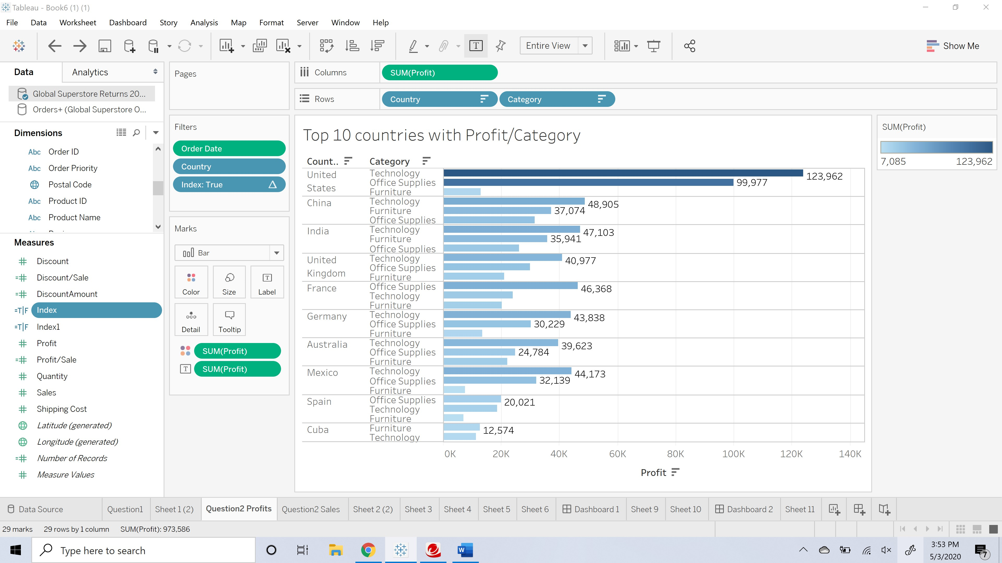

**Conclusion:**

So, this report show the most profitable country based on the profits per product category with labeling as well.

**References:**

1. Tableau training sections.
2. Class learning modules.

**To find out lease sales:**

**Title:** Aim is to detect countries which has the least sales per product category during the last three years.

**Summary:** Drawing the least sales country from the plot of sales per product category.

**Introduction:**

We consider mainly the orders dataset and used the data that is required to obtain the desired result of visualization. Our main purpose is to get the country which has least sales per product category.

**Methods and findings:**

To draw a required visualization from the requirement we need to follow the instructions.

* After trying different graphs and plots, this horizontal bar graph helps us to visualize the report in the most efficient way.
* Drag and drop the country and category from dimensions to the rows.
* Drag and drop the sum of sales to the text, color in marks and on to the columns as well.
* To get the last three years data we use filters on order date and select only the years that are required.
* Now create a new parameter and name it as index which carries a mathematical equation to measure the top few countries which has least sales.

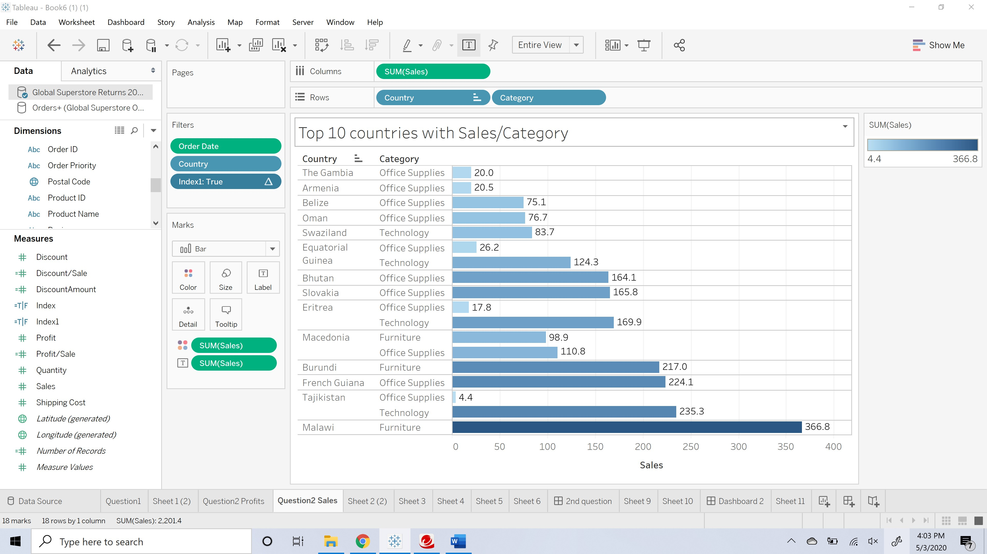

**Conclusion:**

So, this report show the least sales country based on the sales per product category with labeling as well.

We combined most profitable countries and least sales into one dashboard to hve a look side by side.

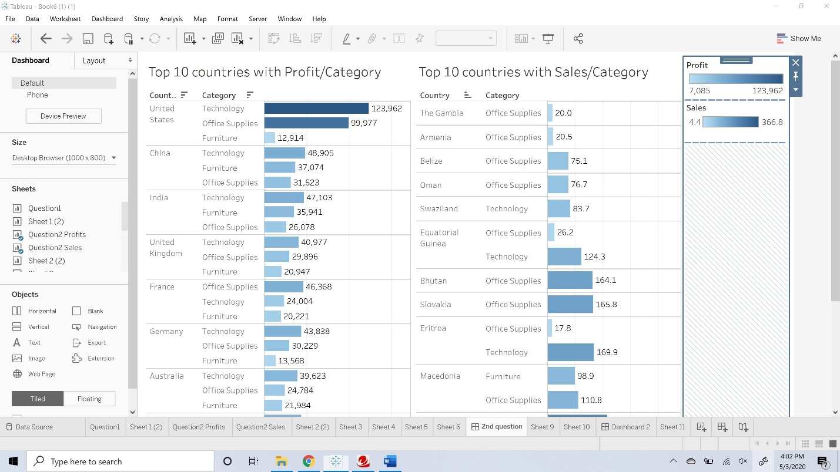

**3. As the company wants to provide a bonus for the top salespeople, find the people with the higher profits and sales during the last five years and depict their performance per product category.**

**Title:** Aim is to detect the top salespeople and find the people with higher profits and sales during the last five years. Also draw their performance per product category for last five years.

**Summary:** Representing the data and drawing conclusions that are based on the requirement which is identifying the top salespeople based on their performances per product category for last five years.

**Introduction:**

We consider dataset which has both returns and orders. Extracting those datasets into the data source and join those datasets to extract every data that is needed to get the visualizations in best possible way. By using the data that is present in the data on the left side of the worksheet.

**Methods and Findings:**

To draw a required visualization from the requirement we need to follow the instructions.

* Create one more measure profit/sale with an equation of Sum of profit/Count of order ID.
* After trying different graphs and plots, these horizontal bars help us to visualize the report in the most efficient way.
* Drag and drop the profit, sales, discount and profit/sales the one we created from measures to the rows.
* Drag and drop the category to the color in marks.
* Drag and drop the person on to the columns.
* Drag and drop order date to the filters.

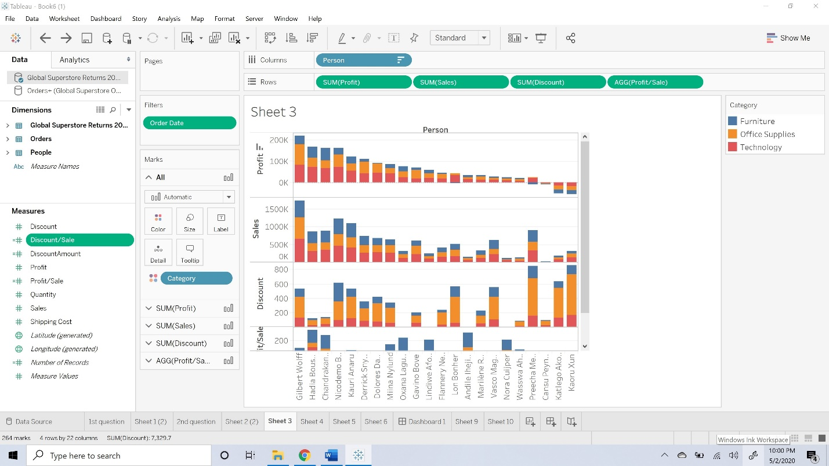

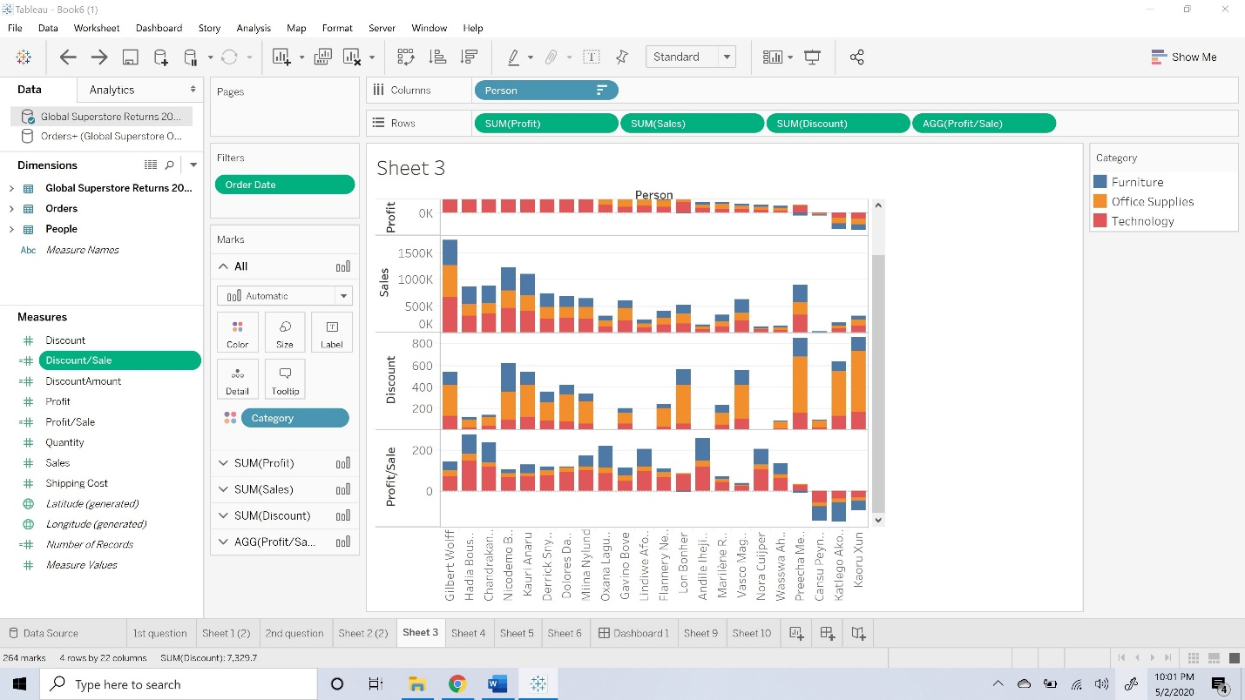

**Conclusion:**

So, this report shows the person who has the best profit, best sales, giving certain discount to improve sales. And finally, with that profit/sales measure we can draw the person who made the better profits.

**References:**

1. Tableau training sections.
2. Class learning modules.

**4. Discuss the number of returns compared with number of sales orders for the last three years.**

**Title:** Comparison between returns and sales

**Summary:** In this report we are planning to compare uber of returns with total number of sales for the last three years in the company.

* We used Orders data set to get the total number of sales and we used returns data set to check on number of returns from the sales.

**Introduction:**

We considered both returns and orders data sets to compare the numbers. We joined both data sets using full outer join. We can compare both returns and sales using Bar graph for three years individually. With this Bar graph, we can clearly call out the comparison ratio for returns with total sales and thus can help us to focus more on increasing returns.

**Methods and findings:**

To draw the required visualization from the requirement we need to follow the instructions.

* We used OrderId from Orders data set to get total number of sales and OrderID from returns data set to get how many returns happened in last three years.
* After trying different graphs and charts, this side by side bar graphs helps us to visualize the report in the most efficient way.
* Drag and drop the OrderID from orders dataset and orderID from returns data set to rows which combines it to Measure Values.
* Drag and drop Order Date to columns and choose year and select last three years on filter.
* Select side-by-side Bar graph
* Drag and drop measure names to colors.

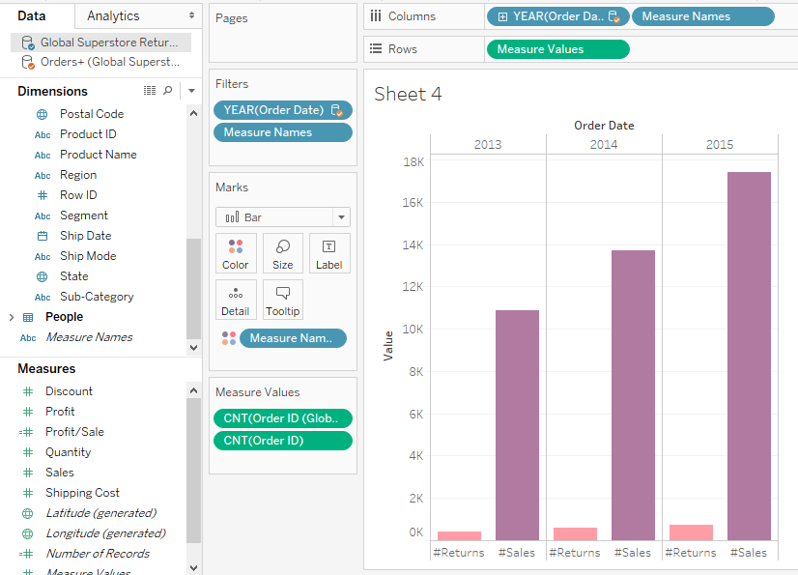

**Conclusions and Recommendations:**

With this report we can see returns are way less than sales. We can also say that returns increased year after year as sales also increased. So we can say That percentage of increase in sales is higher than the percentage increase in returns over the years.

**References:**

1. Tableau training sections.
2. Class learning modules.

**5. Create a data-driven story providing the key points of the company during the last three years and make suggestions about future actions. If you wish you can also use other data from open data sources to strengthen your recommendations.**

**Title:** Data driven story and recommendations

**Summary:** In this report we are going to create a story with the data available and make recommendations from it. We can create multiple stories from the data we have, here we created one such story.

**Introduction:**

We considered orders data to create a story on how profits per sale looks over the last three years when we apply discounts. We used combination of stacked bars and lines graph to make this story effective.

**Methods and findings:**

To draw the required visualization from the requirement we need to follow the instructions.

* After trying different graphs and charts, this stacked bar and line chart graph helps us to visualize the report in the most efficient way.
* Drag and drop the Order date to columns as change it to quarters and apply filter for last three years.
* Drag and drop category to rows.
* Select stack bar graph and select measure values – sales and discount amount.
* Drag and drop measure names to colors.
* Drag and drop measure names to the filter and select only sales and discount
* Create a new measure field named profit/Sale with the calculation of “sum([Profit])/Count([Order ID])” and drag and drop to rows
* Drag and drop profit/sale to the rows and select path as line.
* Go to Analysis tab and make stack marks off.
* Make the view as Entire view
* Make the orderdate field as continuous instead of discrete.

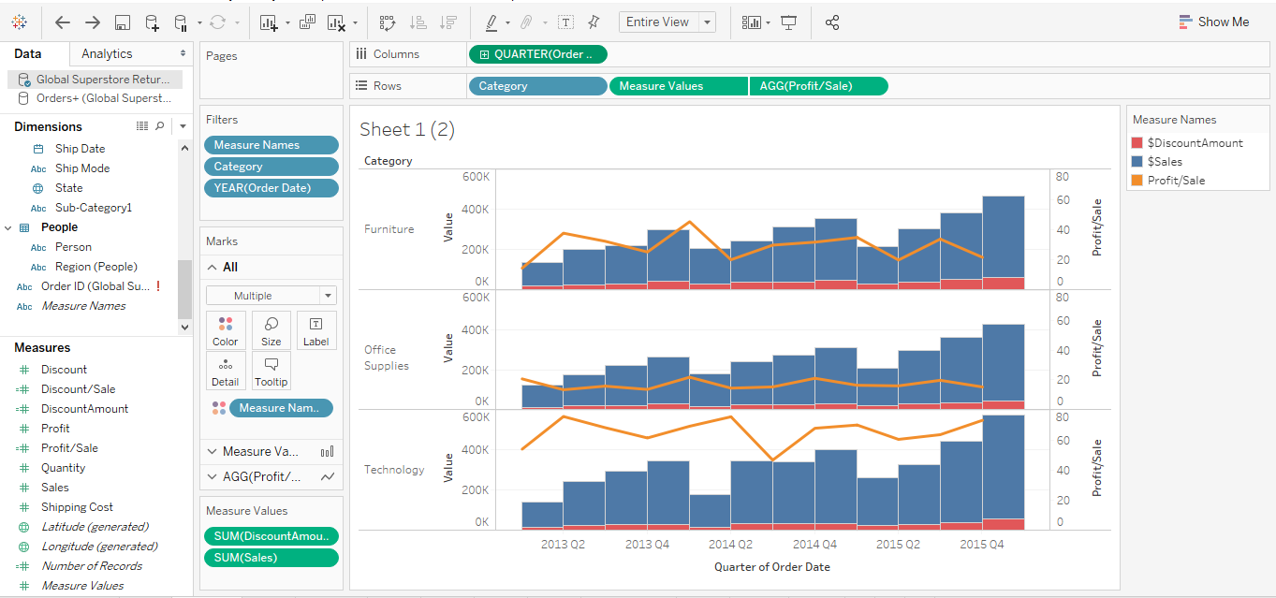

**Conclusions and Recommendations:**

In this visualization we can draw multiple conclusions followed by recommendations

1. Every year Q1 and Q2 months has more sales. Hence, we recommend to increase production in these months.
2. Every year Q4 we see more discounts given to customers but we can see Profile/each sale is coming down in Q3 and Q4.

We can add more stories from the visualization done in question 2.

1. We can see clearly United states makes the most profits and “The Gambia” makes the less sales. We can concentrate more on these countries to expand the business.
2. We can see few countries doesn’t have sale son all categories. We should plan on how to expand business on these categories in particular.

**References:**

1. Tableau training sections.
2. Class learning modules.

**6. Identify trends of profits per category and segment over time. Describe the trend lines model and discuss the results of your analysis.**

**Title:** How the trends looks for profits per category and segments

**Summary:** In this report we are planning to look how the profit trend looks per category and per segment.

* We used Orders data set alone to get the desired result.
* We used segments, category, profits, order date from orders data set.

**Introduction:**

Let’s consider Order data set. We used Lines graph to see how the line exponentially increased over time. Using this we will get how profit increased or decreased over time w.r.t segments. So, we will get to see for each segment how profit works per each category. This goal of ours works perfectly with Lines graph as shown below.

**Methods and findings:**

To draw the required visualization from the requirement we need to follow the instructions.

* After trying different line/discrete/dual line graphs, this Line graph helps us to visualize the report in the most efficient way.
* Drag and drop the Order Date to Columns and exclude null if any found.
* Drag and drop Profits to rows and add segments also to rows.
* Select Lines graph
* Drag and drop Category to colors.
* Go to Analytics tab and choose Trend lines. Drag and Drop Trend lines anywhere in the graph.
* Right click on graph and select edit Trend lines and unselect “Allow a trend line per color” option.

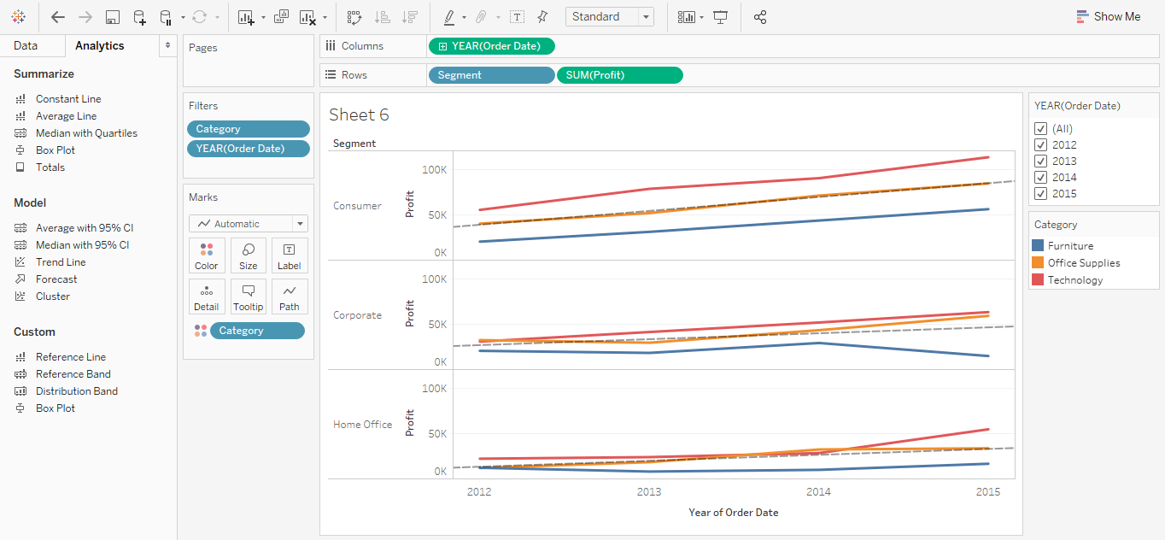

**Conclusions and Recommendations:**

With this report we can draw below conclusions

* Consumer segment profits increases over time in each product category. Furniture profits are always less than the trend line but they increased over time.
* In Corporate segment, furniture profits are just below the trend line in the year 2012 and over the time profits reduced way more than the expected trend.
* In Home Office segment, Furniture profits same as the trend line in 2012 but reduced over the time. Technology profits are same as trend in 2012 but increased more than the trend over time.

So, we can say Technology Profits increased over time in every segment and Furniture profits reduced over time in each segment and Office supplies are at trend level in every segment. We recommend to increase production in Technology and office supplies and reduce production on furniture.

**References:**

1. Tableau training sections.
2. Class learning modules.

**7. Forecast how sales and profits will be evolved in the following year (2016).**

**Title:** 2016 sales and profits forecast data

**Summary:** In this report we are planning to forecast how the profits and sales looks in 2016.

* We used Orders data set alone to get the desired result.
* We used Profits, Sales, profits, order date from orders data set.

**Introduction:**

Let’s consider Order data set. We used Lines graph to see how the profits and sales changed over time. To forecast any data, we need minimum two points of past data. Using the past data we can forecast how sales and profits looks like in the next upcoming year.

**Methods and findings:**

To draw the required visualization from the requirement we need to follow the instructions.

* After understanding the requirement, we understood Line graph helps us to visualize the report in the most efficient way.
* Drag and drop the Order Date to Columns and exclude null if any found. Edit tis to quarters to get more data points for visualization.
* Drag and drop Profits to rows and Sales also to rows.
* Select Lines graph
* Drag and drop Sales and profits to Text in their individual sections to display the values.
* Go to Analytics tab and choose forecast. Drag and Drop forecast anywhere in the graph.

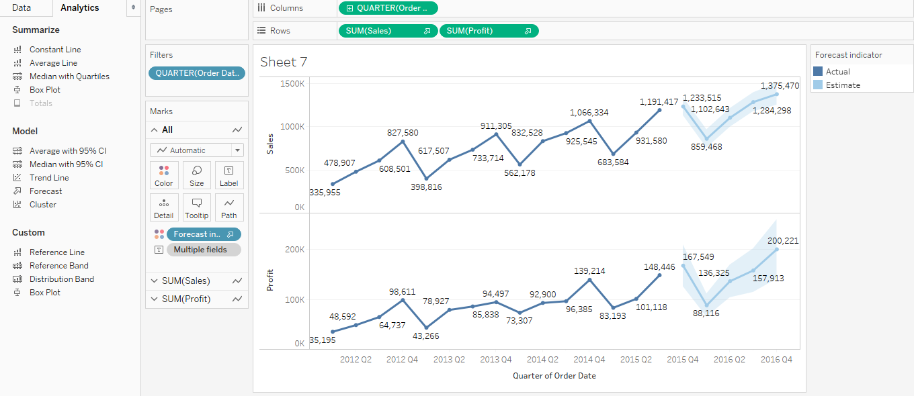

**Conclusions and Recommendations:**

Using this report, we can say both sales and profits reduced from 2015 Q4 to 2016 Q1 and again exponentially increased from 2016 Q1 to 2016 Q4. As sales increases profit increases so this conclusion fits for both sales and profits in the upcoming years.

So, we can recommend, to reduce production in Q1 and prepare for more sales in Q2 and then increase more production in Q3 and highest demand will be in Q4 .

**References:**

1. Tableau training sections.
2. Class learning modules.

Here we added the workbook we created to make these visualization requested.

